NAME:R SRIJA
HALLTICKET NUMBER:2303A51043
BATCH:01 ASSIGNMENT – 01
QUESTION 1 :
AI-Generated Logic Without Modularization (Factorial without Functions)
• Scenario
You are building a small command-line utility for a startup intern onboarding task. The program is simple and must be written quickly without modular design.
• Task Description
Use GitHub Copilot to generate a Python program that computes a mathematical product-based value (factorial-like logic) directly in the mainexecution flow, without using any user-defined functions.
• Constraint:
➢ Do not define any custom function
➢Logic must be implemented using loops and variables only
• Expected Deliverables
➢ A working Python program generated with Copilot assistance
➢ Screenshot(s) showing:
➢ The prompt you typed
➢ Copilot’s suggestions
➢ Sample input/output screenshots
➢ Brief reflection (5–6 lines):
➢ How helpful was Copilot for a beginner?
➢ Did it follow best practices automatically?
CODE:
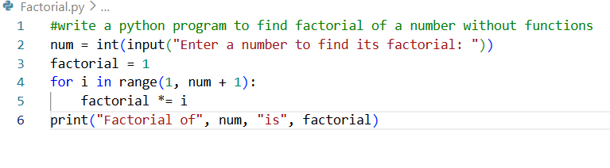
OUTPUT:
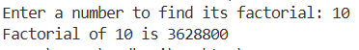
• Expected Deliverables :
Brief Reflection:
GitHub copilot was very helpful for the begginers it will help to learn code and the logics behind it and they can learn how to use ai tools and they will know the difference between how the ai is writing or giving the code and how the human is writing the code so it has many advantages by using this git hub tool
It reduced the time required to write basic logic and avoided syntax errors.
Task 2: AI Code Optimization & Cleanup (Improving Efficiency)
❖ Scenario
Your team lead asks you to review AI-generated code before committing it to a shared repository.
❖ Task Description
Analyze the code generated in Task 1 and use Copilot again to:
➢ Reduce unnecessary variables
➢ Improve loop clarity
➢ Enhance readability and efficiency
Hint:
Prompt Copilot with phrases like
“optimize this code”, “simplify logic”, or “make it more readable”
❖ Expected Deliverables
➢ Original AI-generated code
➢ Optimized version of the same code
➢ Side-by-side comparison
➢ Written explanation:
▪ What was improved?
▪ Why the new version is better (readability, performance, maintainability
CODE:
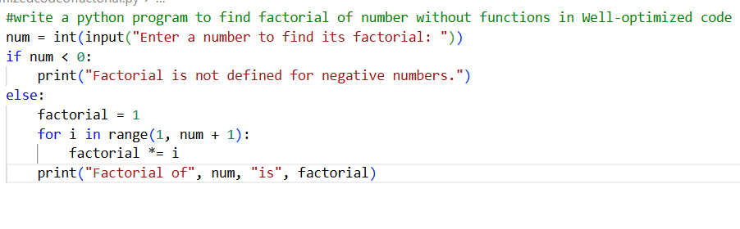
OUTPUT:
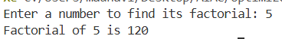
Why the New Version Is Better:
- Readability: The logic is easier to understand at a first
- Performance: Avoids one loop iteration.
- Maintainability: Clear variable names and cleaner syntax make future changes simpler.
- Best Practices: Uses modern Python and concise expressions.

Task 3: Modular Design Using AI Assistance (Factorial with Functions)
❖ Scenario
The same logic now needs to be reused in multiple scripts.
❖ Task Description
Use GitHub Copilot to generate a modular version of the program by:
➢ Creating a user-defined function
➢ Calling the function from the main block
❖ Constraints
➢ Use meaningful function and variable names
➢ Include inline comments (preferably suggested by Copilot)
❖ Expected Deliverables
➢ AI-assisted function-based program
➢ Screenshots showing:
o Prompt evolution
o Copilot-generated function logic
➢ Sample inputs/outputs
➢ Short note:
o How modularity improves reusability.
CODE:
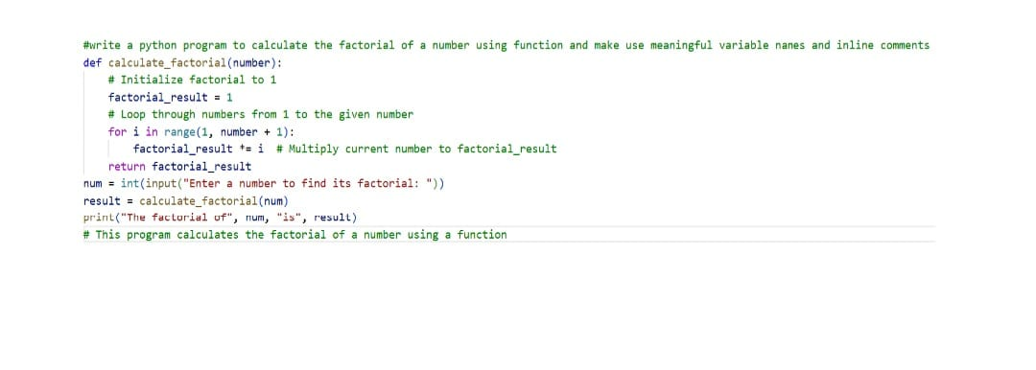
OUTPUT:
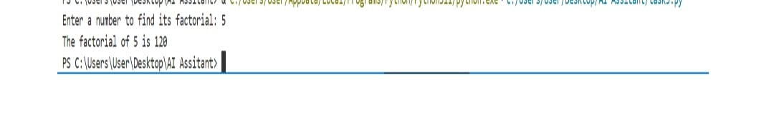
NOTES ON MODULARITY:
Modularity means dividing a program into small units called modules or functions. Modular code is easier to test, debug, and maintain because changes in one module do not affect the entire program. And modularity has many advantages we can use the code multiplke items when we will write code once.
Task 4: Comparative Analysis – Procedural vs Modular AI Code (With vs Without Functions)
❖ Scenario
As part of a code review meeting, you are asked to justify design choices.
❖ Task Description
Compare the non-function and function-based Copilot-generated
programs on the following criteria:
➢ Logic clarity
➢ Reusability
➢ Debugging ease
➢ Suitability for large projects
➢ AI dependency risk
❖ Expected Deliverables
Choose one:
➢ A comparison table
OR
➢ A short technical report (300–400 words).
CODE:
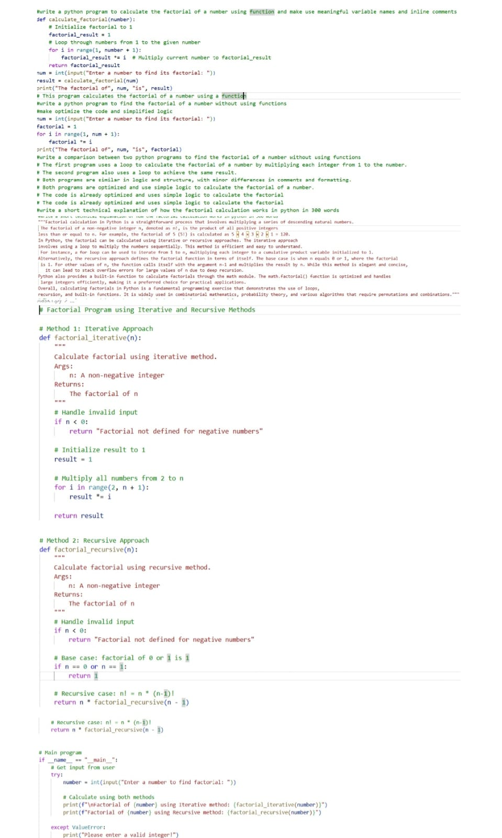
Task 5: AI-Generated Iterative vs Recursive Thinking
❖ Scenario
Your mentor wants to test how well AI understands different computational paradigms.
❖ Task Description
Prompt Copilot to generate:
An iterative version of the logic
A recursive version of the same logic
❖ Constraints
Both implementations must produce identical outputs
Students must not manually write the code first
❖ Expected Deliverables
Two AI-generated implementations
Execution flow explanation (in your own words)
Comparison covering:
➢ Readability
➢ Stack usage
➢ Performance implications
➢ When recursion is not recommended.
CODE:
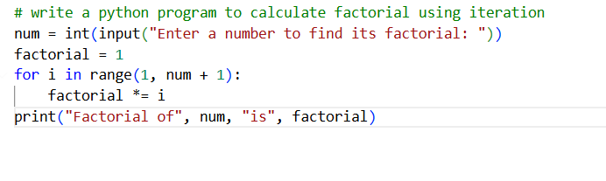
OUTPUT:
